SanDisk Extreme M.2 NVMe PCIe Gen 4.0 Internal SSD - 500GB

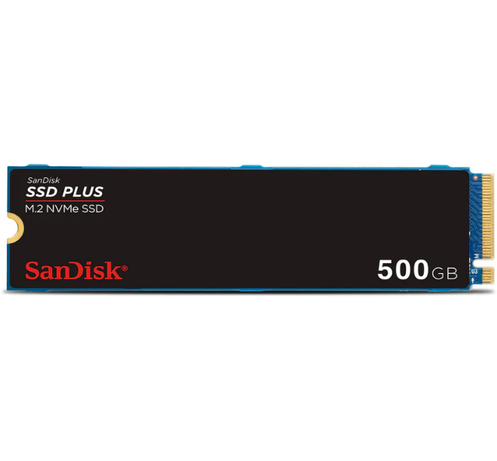

**Key Specifications:**

* **Capacity**: 500GB
* **Interface**: PCIe Gen 4.0 x4, NVMe 1.4
* **Form Factor**: M.2 2280
* **Sequential Read Speed**: Up to 3,600 MB/s
* **Sequential Write Speed**: Up to 2,800 MB/s

**Advanced Technology:**

* **NVMe Protocol**:  
  Delivers enhanced speed and performance compared to traditional SATA SSDs.
* **Thermal Management**:  
  Built with heat-dissipation technology to prevent thermal throttling during extended use.

**Energy Efficiency:**

* Consumes less power than traditional HDDs, making it ideal for laptops and eco-conscious setups.

**Warranty:**

* Backed by a **5-year limited warranty**, ensuring reliable performance and customer support.